Data Processing and Presentation

Name:
Professor:
Course:
Date:

- Types of data
  - One of the key considerations that the Ministry of Transportation Ontario (MTO) has put in place is identification of less costly materials that can be used to help in the alleviation of CO2 emissions. MTO develops standards that are adhered to by contractors to enhance the construction of buildings, roads, and other infrastructure, with the aim of having zero carbon emissions by 2030. Hertwich et al., (2019) argues that it is necessary to use efficient materials, which are less costly and capable of minimizing carbon dioxide emissions. The materials that will be used to ensure that the 250 Yonge Street Building has limited emissions will be based on asphalt, rather than concrete. MTO has set specific standards, which are used in the process of modifying base requirements. Items that involve the use of concrete in the construction of this building include pavements and concrete base, concrete barriers, structures, overlays, and patches. For the case of this building, asphalt will be used because of its durability, aesthetic value, cost, moisture protection from the sun.
  - Materials that will be used for the base construction in asphalt include tars, stone mastic asphalt, coal tar, and pitch. Materials that will be used for the base of this project are crushed gravel like granite c-5 and limestone c-5. The soil in this site is not loose, thus using these materials will offer a stronger foundation.
  - Stone mastic asphalt is composed of bitumen, calcareous fines, sand, chippings, and asphalt powder. This material is chosen because it can be worked on when it is hot, has a good wear resistance, and it is water proof. Coal tar will be produced through plasticization of coal, coal tar pitch, and distillates (Diaz et al., 2016).
To cover the base of the building (812,6381 sq. feet), the following cost estimates were made.
Concrete driveway removal will cost $6 per square foot
Subgrade layer: 3-8 inches of aggregate material for asphalt bed. Manual installation and grading will cost $1.35 per square foot.
Base layer based on MTO standards: 2 inches base layer and 1-inch top coat. Estimated cost is $1.40 and $1.10 per square feet respectively.
Sealing cost after curing is $0.75 per square foot.
Cost estimates for asphalt base was obtained from best industry practices and MTO.
Calculations for area and perimeter
  - The building has 812638 sq. ft.
Ventilation – there are 2 makeup air units, a variable air volume floor air distribution and variable fan drives.
There are 4 feet lighting fixtures with a generic electric lighting control.
Of the total 812638 sq feet, the area is divided into 8 sections
financial services section | legal services section | Real estate and infrastructure | fitness center section | government section | Medical services section | IT services section | Other sections
67% | 9% | 8% | 5% | 4% | 4% | 3% | 1%
544467.46 sq.ft | 73137.42 sq.ft | 65011.04 sq.ft | 40631.9 sq.ft | 32505.52 sq.ft | 32505.52 sq.ft | 24397.14 sq.ft | 8126.38 sq.ft
  - Ontario building code. In this project, construction and demolition code and property standards will be addressed as proposed by the Building Code Act, 1992, S.O. 1992, c. 23.
  - Engineering blueprints
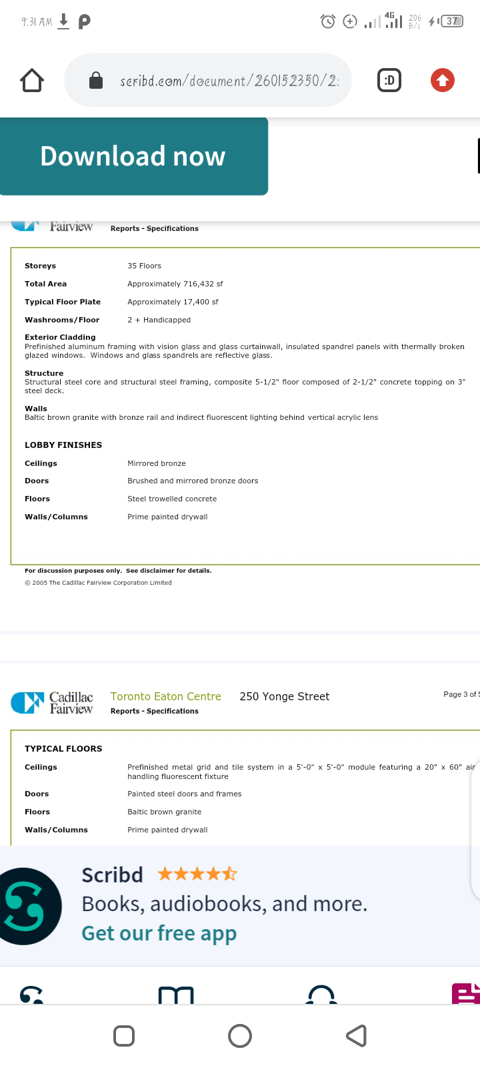
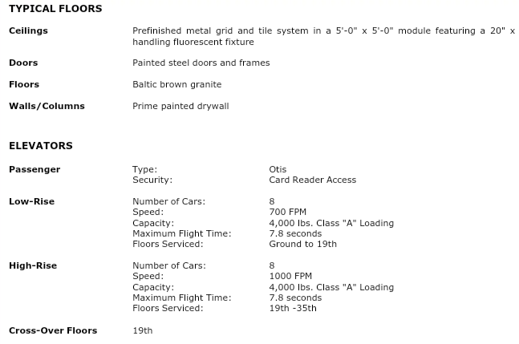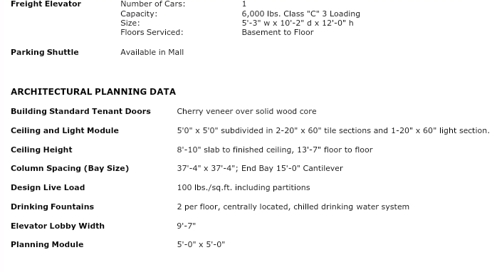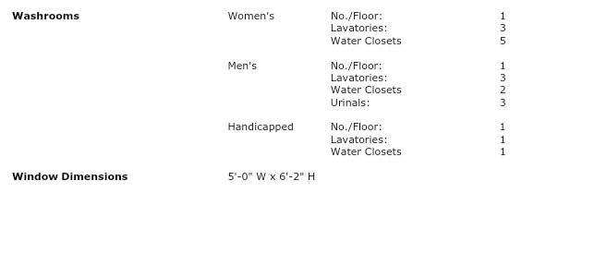
- Sources of data
- 250 Yonge Street, Toronto Greenhouse Gas Inventory Report. (, 2013). Retrieved 7 October 2020, from https://www.csaregistries.ca/files/projects/2301-2780_GHGReport_20110401_201203311.pdf.
- Dakwale, V., &Ralegaonkar, R. (2011). Review of carbon emission through buildings: threats, causes, and solutions: Table 1. International Journal of Low-Carbon Technologies, 7(2), 143-148. https://doi.org/10.1093/ijlct/ctr032
- Diaz, R. O., Montanez, A., & Cuentas, J. (2016). Coal tar, material used in soil improvement for use in road engineering. In J. Phys. Conf Ser (687, p. 12045).
- Hertwich, E., Ali, S., Ciacci, L., Fishman, T., Heeren, N., &Masanet, E. et al. (2019). Material efficiency strategies reduce greenhouse gas emissions associated with buildings, vehicles, and electronics—a review. Environmental Research Letters, 14(4), 043004. https://doi.org/10.1088/1748-9326/ab0fe3
- Huang, W., Li, F., Cui, S., Li, F., Huang, L., & Lin, J. (2017). Carbon Footprint and Carbon Emission Reduction of Urban Buildings: A Case in Xiamen City, China. Procedia Engineering, 198, 1007-1017. https://doi.org/10.1016/j.proeng.2017.07.146
- Mohareb, E., &Mohareb, A. (2014). A comparison of greenhouse gas emissions in the residential sector of major Canadian cities. Canadian Journal of Civil Engineering, 41(4), 285-293.https://doi.org/10.1139/cjce-2013-0465
- Data storage
Data on the cost of materials that will be used for this project will be stored using excel sheet, tables, and in the appendix. Excel sheets will be used to categorize all materials used, where they will be sourced from, and their costs. Using excel sheets to store the processed data will ensure that it is clear and arranged in a logical order. The engineering blueprints data will be presented in the body of the report and in the appendix. Storing this data in the body will ensure that all explanations and details are discussed. Also, using the appendix will ensure that there is a logical flow of information.
- Data processing
The cost of materials for this project will need to be analyzed to determine the total costs and address any issues of uncertainty.
Data of the blueprints will also be analyzed to ensure that the project is well mapped and no details are overlooked.
- Types of data analysis
For this project to be a success, three types of data analysis will be used.
Descriptive analysis: It will show the performance of the building using the current architectural design and how the design has led to increased emissions.
Diagnostic analysis: Will be used to determine the causes of increased emissions from the building.
Prescriptive analysis: will be performed to provide insights about the approaches of preventing carbon emissions from 250 Yonge Street building.
- Data analysis steps
The descriptive analysis will be conducted using previous data on the rate of emissions, the cost of maintaining the building, and its impact to the local population. This analysis will be performed using data from MTO. A descriptive analysis will be performed to determine how the architectural design and the materials used have contributed to an increase in carbon emissions.
A diagnostic analysis will be performed to determine why the building emits up to 35% of carbon emissions in the site. The first step will be to analyze the blueprints to ascertain how water will be supplied in the building, how heating and cooling will be regulated, and how electrical systems will be installed. An analysis of the façade material will be performed to determine how aluminium contributes towards increased emissions. The effects of using a centrally controlled air conditioning and a forced air heating type will be addressed. Also, the height from floor to floor and floor to ceiling will be analyzed to estimate its contributions to the current problem.
A prescriptive analysis will be conducted to provide the most viable solutions to alleviate C02 emissions. This analysis will basically rely on artificial intelligence (AI) systems that will communicate informed decisions based on the insights obtained from the descriptive and diagnostic analysis.
- Presentation of results
After analysis, the results will be presented using tables, graphs, and statistics. Tables will be used to show costs of materials used and the rate of carbon emissions from different sections of the building. Graphs will be used to show carbon emission trends based on the existing design and the proposed design. Lastly, statistics will be used to show cost estimates of materials and the expected levels of carbon emissions.

References
250 Yonge Street, Toronto Greenhouse Gas Inventory Report. (, 2013). Retrieved 7 October 2020, from https://www.csaregistries.ca/files/projects/2301-2780_GHGReport_20110401_201203311.pdf.
Dakwale, V., &Ralegaonkar, R. (2011). Review of carbon emission through buildings: threats, causes, and solutions: Table 1. International Journal of Low-Carbon Technologies, 7(2), 143-148. https://doi.org/10.1093/ijlct/ctr032
Diaz, R. O., Montanez, A., & Cuentas, J. (2016). Coal tar, material used in soil improvement for use in road engineering. In J. Phys. Conf Ser (687, p. 12045).
Hertwich, E., Ali, S., Ciacci, L., Fishman, T., Heeren, N., &Masanet, E. et al. (2019). Material efficiency strategies reduce greenhouse gas emissions associated with buildings, vehicles, and electronics—a review. Environmental Research Letters, 14(4), 043004. https://doi.org/10.1088/1748-9326/ab0fe3
Huang, W., Li, F., Cui, S., Li, F., Huang, L., & Lin, J. (2017). Carbon Footprint and Carbon Emission Reduction of Urban Buildings: A Case in Xiamen City, China. Procedia Engineering, 198, 1007-1017. https://doi.org/10.1016/j.proeng.2017.07.146
Mohareb, E., &Mohareb, A. (2014). A comparison of greenhouse gas emissions in the residential sector of major Canadian cities. Canadian Journal of Civil Engineering, 41(4), 285-293.https://doi.org/10.1139/cjce-2013-0465

